Bahria University,

Karachi Campus



Course: CSL 220 Database management systems Lab

Term: Spring 2022, Class: BSE- 4(B)

Submitted By:

Abdul Quddos 69984

(Name) (Reg. No.)

Submitted To:

Mam Laraib Siddique/Engr. Ayesha Khan

Signed Remarks: Score:

INDEX

|  |  |  |  |  |
| --- | --- | --- | --- | --- |
| SNO | DATE | LAB NO | LAB OBJECTIVE | SIGN |
|  |  |  |  |  |
|  |  |  |  |  |
|  |  |  |  |  |
|  |  |  |  |  |
|  |  |  |  |  |
|  |  |  |  |  |
|  |  |  |  |  |
|  |  |  |  |  |
|  |  |  |  |  |
|  |  |  |  |  |
|  |  |  |  |  |
|  |  |  |  |  |
|  |  |  |  |  |
|  |  |  |  |  |
|  |  |  |  |  |
|  |  |  |  |  |
|  |  |  |  |  |
|  |  |  |  |  |
|  |  |  |  |  |
|  |  |  |  |  |

Bahria University,

Karachi Campus



LAB EXPERIMENT NO.

1

LIST OF TASKS

|  |  |
| --- | --- |
| TASK NO | OBJECTIVE |
|  |  |
|  |  |
|  |  |
|  |  |
|  |  |
|  |  |
|  |  |
|  |  |
|  |  |
|  |  |

Submitted On:

(Date: //)

**LAB # 04**

**Task # 09:**

**Solution:**

select orders.orderid,shippers.companyname from shippers inner join orders on orders.shipvia = shippers.shipperid

**Output:**

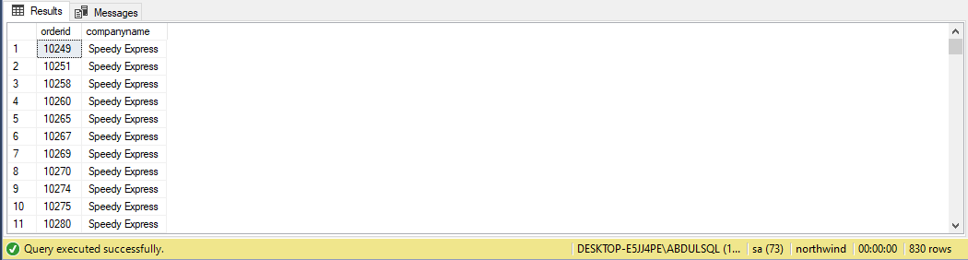

Task = 11:

select region.regionid,region.regiondescription,territories.territorydescription from region inner join territories on region.regionid = territories.regionid

Solution:

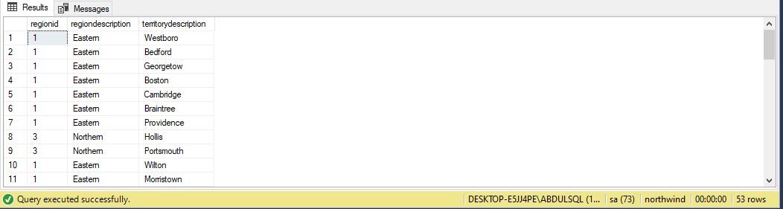

Task 12:

select customers.companyname,count(orders.customerid) from customers inner join orders on customers.customerid = orders.customerid group by customers.companyname

Solution:

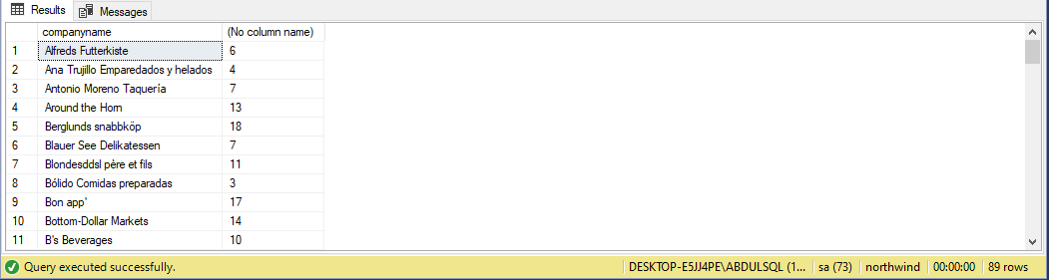

Task1:

select products.productname,categories.categoryname from products left join categories on products.productid = categories.categoryid where products.productname like 'b%'

Solution:

